
RAJALAKSHMI INSTITUTE OF TECHNOLOGY
(An Autonomous Institution, Affiliated to Anna University, Chennai)

DEPARTMENT OF ARTIFICIAL INTELLIGENCE AND DATA SCIENCE
ACADEMIC YEAR 2025 - 2026
SEMESTER IV
AL23421 - MACHINE LEARNING LABORATORY
MINI PROJECT REPORT

REGISTER NUMBER | 2117240070003
NAME | ABDUS SALAAM A
PROJECT TITLE | Laptop Price Prediction Using Linear Regression Algorithm
DATE OF SUBMISSION
FACULTY IN-CHARGE | Mrs. M. Divya

Signature of Faculty In-charge Signature of HoD

INTRODUCTION
Machine Learning (ML) is a subset of Artificial Intelligence that enables systems to learn patterns from data and make predictions without being explicitly programmed. In this project, the Laptop Price Prediction system uses Linear Regression, which is a supervised learning algorithm used for predicting continuous numerical values. It works by establishing a relationship between input features and the target variable to estimate outcomes.
For the given problem of predicting laptop prices based on specifications, this algorithm is highly suitable because:
- It can model relationships between multiple input features such as RAM, storage, and weight
- It is simple, efficient, and easy to interpret
- It provides reliable predictions for continuous data like price
In this system, laptop specifications such as RAM, CPU type, storage (SSD/HDD), weight, and brand are first preprocessed and converted into a machine-understandable format using encoding techniques like one-hot encoding. The Linear Regression model then learns the relationship between these features and the laptop price to predict the estimated cost of a laptop.
The problem addressed in this project is the difficulty users face in determining whether a laptop is fairly priced based on its specifications. With a wide variety of brands and configurations available in the market, it becomes challenging for consumers to make informed decisions. Additionally, sellers and businesses require efficient tools to estimate pricing accurately.
This issue is particularly important in the modern digital era, where laptops are essential for education, work, and personal use. Incorrect pricing or lack of awareness can lead to poor purchasing decisions or financial loss.
The Laptop Price Prediction system aims to solve this problem by providing:
- Accurate price estimation based on laptop specifications
- Quick and data-driven decision support
- A user-friendly interface for easy interaction
The objective of this project is to develop an intelligent and interactive system that predicts laptop prices using Machine Learning and presents the results through a simple web application built with Streamlit. This allows users to input specifications and instantly receive estimated prices.
The model is trained on a dataset containing various laptop features and corresponding prices, enabling it to learn patterns and relationships between specifications and cost. By using Linear Regression, the system ensures a balance between simplicity and predictive performance.
Overall, this project serves as a practical application of Machine Learning that assists users in making better purchasing decisions and demonstrates how data-driven models can be used to solve real-world problems efficiently.

PROBLEM STATEMENT
Determining the correct price of a laptop based on its specifications is a challenging task for many users due to the wide variety of configurations and brands available in the market. Consumers often lack the technical knowledge required to evaluate whether a laptop’s price is reasonable for its features, such as RAM, processor, storage, and build quality. As a result, they may end up overpaying or purchasing devices that do not meet their requirements.
Additionally, the rapid growth of the technology market has led to frequent changes in pricing and specifications, making it even more difficult for users to stay updated. Sellers and businesses also face challenges in setting competitive and accurate prices for laptops based on varying configurations and market trends.
There is a need for an intelligent system that can analyze multiple laptop features and provide accurate, quick, and accessible price predictions. The problem is to develop a machine learning-based solution that takes laptop specifications as input and predicts the estimated price, helping users make informed purchasing decisions and assisting sellers in pricing their products effectively.
GOAL
The goal of this project is to develop an intelligent and reliable system that can predict laptop prices based on user-provided specifications using machine learning techniques. The expected result is an accurate and efficient prediction model that assists users in estimating the cost of laptops and making informed purchasing decisions.
The system aims to provide:
- Accurate price predictions based on multiple laptop features
- Quick and real-time analysis for immediate feedback
- User-friendly interaction for easy input of laptop specifications
Additionally, the project opens up several possibilities, such as:
- Assisting customers in selecting laptops within their budget
- Helping sellers and businesses set competitive and fair prices
- Integrating with e-commerce platforms for smart pricing systems
- Expanding the model with larger datasets for improved accuracy and broader market coverage
Overall, the goal is to create a scalable and practical solution that bridges the gap between technical specifications and price understanding, enabling users to make better and more confident decisions.
THEORETICAL BACKGROUND
Laptop price prediction is a regression problem in machine learning. Given a set of input features
X = {x₁, x₂, x₃, ..., xₙ},
the objective is to predict a continuous output value y, which represents the price of the laptop.
The model learns a mapping function:
f(X) → y
where:
X = input feature vector (RAM, storage, CPU, weight, etc.)
y = predicted laptop price
Since the dataset contains both numerical and categorical features, the data is first preprocessed. Numerical values such as RAM and weight are cleaned and converted into proper formats, while categorical variables such as company, type, and CPU are transformed into numerical form using encoding techniques like one-hot encoding.
Linear Regression is a supervised learning algorithm used for predicting continuous values. It models the relationship between input features and the target variable using a linear equation:
y = β₀ + β₁x₁ + β₂x₂ + ... + βₙxₙ
where:
β₀ = intercept
β₁, β₂, ..., βₙ = coefficients
x₁, x₂, ..., xₙ = input features
The model tries to minimize the difference between actual and predicted values using a loss function such as Mean Squared Error (MSE):
MSE = (1/n) × Σ (yᵢ − ŷᵢ)²
Lower MSE indicates better prediction accuracy.
Various machine learning algorithms can be applied to price prediction systems. Decision Trees are easy to understand but tend to overfit on complex datasets. Random Forest improves accuracy by combining multiple trees but increases computational complexity. Support Vector Machines (SVM) provide good performance but are harder to tune and scale. K-Nearest Neighbours (KNN) is simple but becomes slow with large datasets.
Linear Regression is selected for this project because it is simple, efficient, and interpretable. It works well when there is a linear relationship between features and the target variable. The algorithm is computationally fast and suitable for real-time prediction systems.
It also provides clear insights into how each feature affects the price, making it useful for analysis. Due to these advantages, Linear Regression is an effective and practical choice for building a laptop price prediction system.
ALGORITHM EXPLANATION WITH EXAMPLE
The Linear Regression algorithm is a supervised learning method used to predict continuous values. It works by finding the best-fit line that represents the relationship between input features and the target variable. Instead of making decisions like classification algorithms, it calculates a weighted sum of input features to estimate the output value.
Mathematically, the predicted value is given by:
ŷ = β₀ + β₁x₁ + β₂x₂ + ... + βₙxₙ
where:
β₀ = intercept
β₁, β₂, ..., βₙ = coefficients learned from the data
x₁, x₂, ..., xₙ = input features
ŷ = predicted price
The model learns the values of coefficients by minimizing the prediction error using techniques like least squares.
Example:
Consider a sample laptop with the following specifications:
RAM = 8 GB
SSD = 256 GB
Weight = 1.5 kg
After preprocessing, this is represented as:
X = [8, 256, 1.5]
Assume the trained Linear Regression model has learned the following equation:
ŷ = 10000 + (3000 × RAM) + (50 × SSD) − (2000 × Weight)
Substituting the values:
ŷ = 10000 + (3000 × 8) + (50 × 256) − (2000 × 1.5)
ŷ = 10000 + 24000 + 12800 − 3000
ŷ = 43800
Final prediction:
ŷ = ₹43,800
So, the model predicts that the estimated price of the laptop is ₹43,800 based on the given specifications.
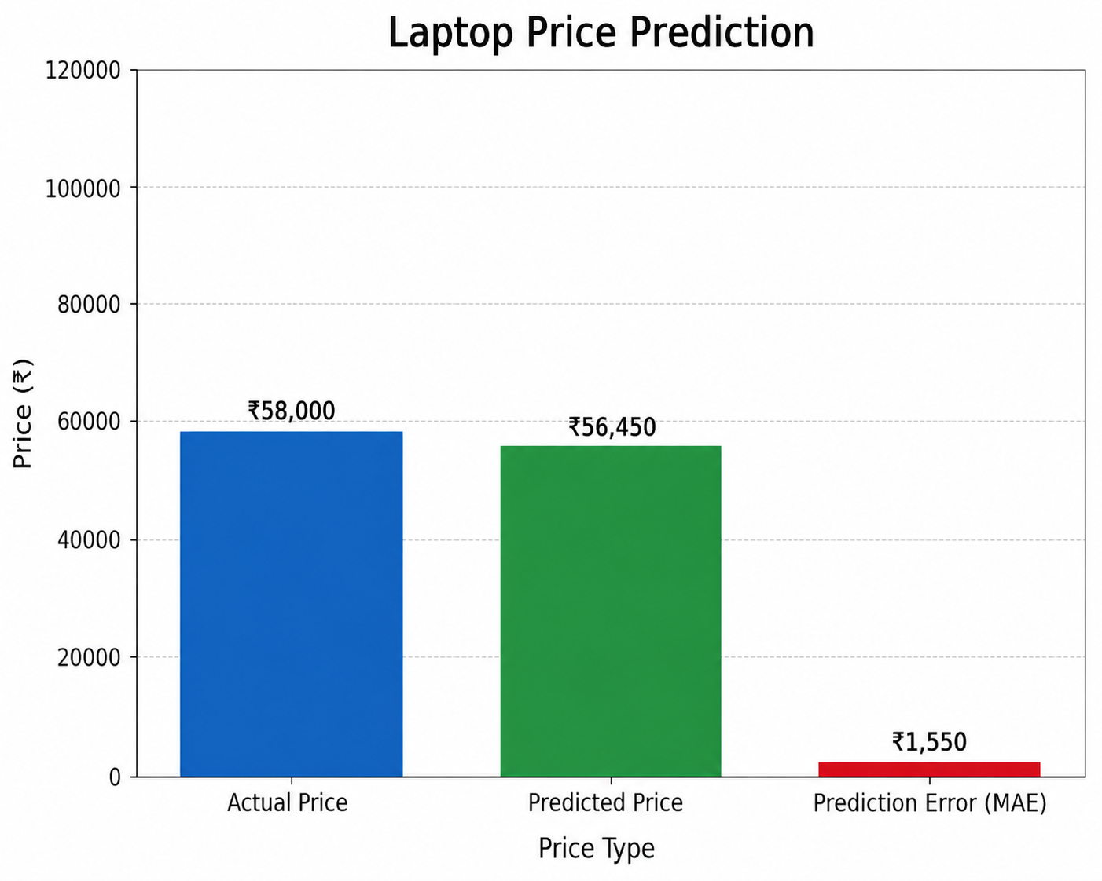

IMPLEMENTATION CODE AND DATASET USED
Dataset : Laptop Price Dataset
Category | Description / Example
Dataset Name | laptop_data.csv
Domain | Electronics / E-commerce
Objective | Regression
Data Source | Public
Number Samples | ~1300 records
Data Type | Tabular
Instance Description | Each row represents a laptop with its specifications and price
Features(Inputs) | Company, TypeName, Inches, CPU, RAM, Memory, GPU, OpSys, Weight
Feature Types | Categorical and Numerical
Target Variable | Price
Number of Classes | Continuous values
License | Open-source
Version | Initial version

Dataset Used: https://www.kaggle.com/datasets/mohidabdulrehman/laptop-price-dataset
Python code
import pandas as pd
import numpy as np
from sklearn.model_selection import train_test_split
from sklearn.linear_model import LinearRegression
import pickle

# ========== Load Data ==========
df = pd.read_csv("laptop_data.csv")

# ========== Clean Column Names ==========
df.columns = df.columns.str.strip()

# Drop unnecessary column
if "Unnamed: 0" in df.columns:
df.drop("Unnamed: 0", axis=1, inplace=True)

# ========== Data Preprocessing ==========

# Clean RAM → "8GB" → 8
df["Ram"] = df["Ram"].str.replace("GB", "").astype(int)

# Clean Weight → "1.37kg" → 1.37
df["Weight"] = df["Weight"].str.replace("kg", "").astype(float)

# Extract CPU type → i3, i5, i7
df["Cpu"] = df["Cpu"].str.extract("(i3|i5|i7)")

# Extract SSD and HDD
df["SSD"] = df["Memory"].str.extract(r"(\d+)GB SSD")
df["HDD"] = df["Memory"].str.extract(r"(\d+)TB HDD")

df["HDD"] = df["HDD"].astype(float) * 1000
df["SSD"] = df["SSD"].fillna(0).astype(int)
df["HDD"] = df["HDD"].fillna(0)

# Drop unused columns
df.drop(["Memory", "Gpu", "ScreenResolution"], axis=1, inplace=True)

# ========== Encoding ==========
df = pd.get_dummies(df, columns=["Company", "TypeName", "Cpu", "OpSys"], drop_first=True)

# ========== Split Data ==========
X = df.drop("Price", axis=1)
y = df["Price"]

X_train, X_test, y_train, y_test = train_test_split(
X, y, test_size=0.2, random_state=42
)

# ========== Train Model ==========
model = LinearRegression()
model.fit(X_train, y_train)

# ========== Save Model ==========
pickle.dump(model, open("model.pkl", "wb"))

print("Model trained and saved successfully!")

OUTPUT
Live Demo - https://igfxnmfmp4nakxwiisfhvq.streamlit.app/

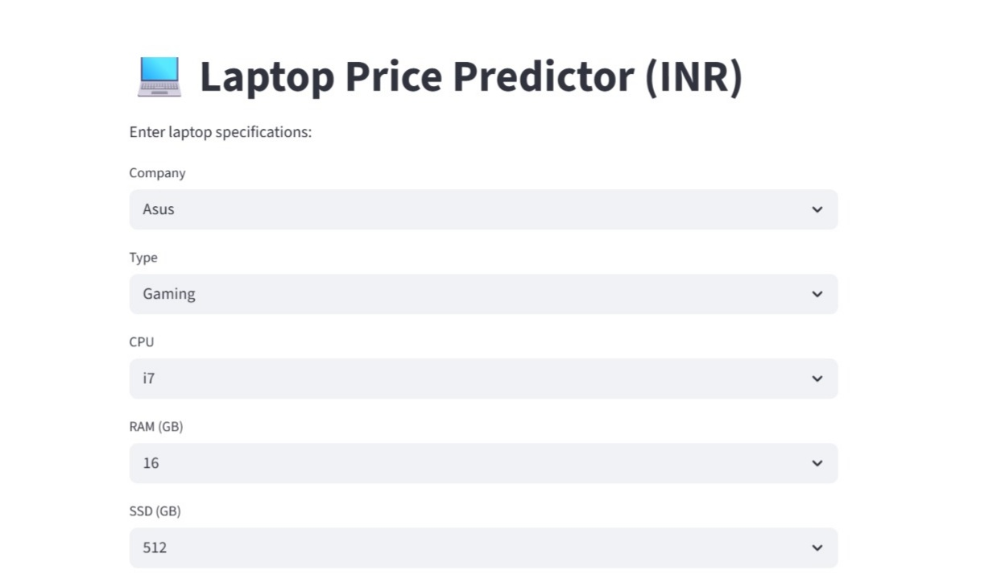
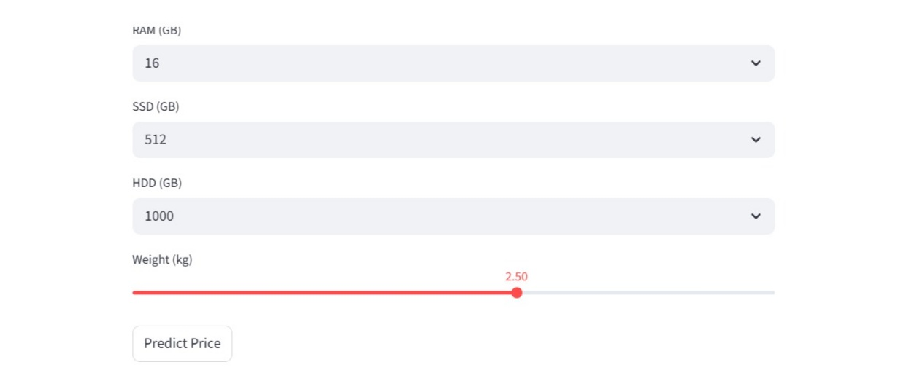
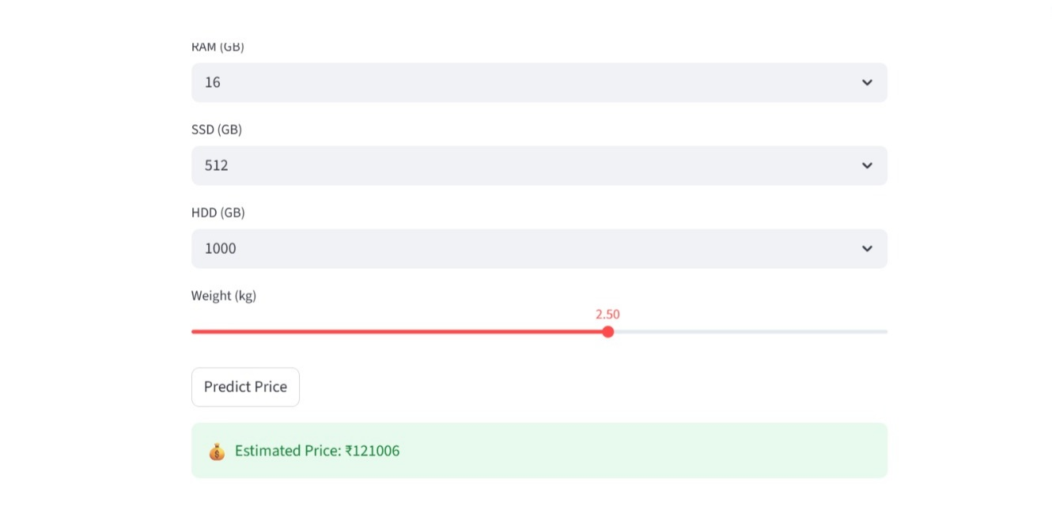
The Laptop Price Prediction system allows users to enter laptop specifications through a user-friendly interface built using Streamlit. Users can select or input features such as company, laptop type, CPU type, RAM, storage (SSD/HDD), and weight.
After clicking the “Predict Price” button, the entered specifications are converted into a numerical format using the same preprocessing and encoding techniques used during model training. The processed input is then passed to the trained Linear Regression model, which predicts the estimated price of the laptop.
The result is displayed instantly on the screen in Indian Rupees (₹), providing users with a quick and clear understanding of the expected price. The system ensures that the prediction is based on learned relationships between laptop features and pricing patterns in the dataset.
The interface is designed to be simple and interactive, allowing users to easily modify inputs and compare different configurations. This helps users explore how different specifications affect the price of a laptop.
Additionally, the system demonstrates how machine learning can be applied in real-world scenarios to assist decision-making. It helps users make better purchasing choices and understand the impact of specifications on pricing.
Overall, the system provides a fast, accurate, and user-friendly solution for estimating laptop prices based on given features.
Performance Metrics Description:
- R² Score (Coefficient of Determination)
R² Score measures how well the model explains the variation in laptop prices. It indicates how much of the price variation is captured by the input features.
For this project, the model achieves a high R² score, showing good prediction capability.
- Mean Absolute Error (MAE)
MAE measures the average absolute difference between actual and predicted prices.
Lower MAE means the model’s predictions are closer to the real values, making it easier to interpret in terms of actual price difference.
- Mean Squared Error (MSE)
MSE calculates the average of squared differences between actual and predicted values.
It penalizes larger errors more heavily, helping to evaluate how well the model handles outliers.
- Root Mean Squared Error (RMSE)
RMSE is the square root of MSE and represents the error in the same unit as the target variable (price).
It provides a clear understanding of how far predictions are from actual prices on average.
- Prediction Output (Estimated Price)
The model provides a predicted price value based on input features.
This value represents the estimated cost of the laptop, helping users understand pricing based on specifications.

RESULTS AND FUTURE ENHANCEMENT
The Laptop Price Prediction system successfully estimates laptop prices based on user-provided specifications using a Linear Regression algorithm. The model achieves good performance with a high R² score and low error values, indicating reliable prediction capability. The system provides instant price predictions through a simple and interactive interface, making it user-friendly and practical.
Compared to traditional methods where users rely on guesswork or manual comparison across different websites, this approach provides a structured and data-driven solution. Users can input specifications and immediately get an estimated price, helping them make informed decisions.
When compared with other algorithms, Linear Regression performs efficiently for this problem due to its simplicity and interpretability. Algorithms like Decision Trees may overfit the data, while Random Forest increases complexity and computational cost. Methods like Support Vector Machines (SVM) and K-Nearest Neighbours (KNN) can provide good accuracy but are slower and harder to scale. In contrast, Linear Regression offers a balance of speed, simplicity, and reasonable accuracy, making it suitable for this application.

Future Enhancements
Despite its effectiveness, the system can be further improved in several ways:
- Integration with real-time market data to improve prediction accuracy
- Inclusion of more laptop features such as battery life, display type, and graphics performance
- Development of a mobile application for better accessibility
- Integration with e-commerce platforms for dynamic price comparison
- Use of advanced models (Random Forest, Gradient Boosting, Deep Learning) for improved accuracy
- Addition of a recommendation system to suggest best laptops within a budget
Overall, the Laptop Price Prediction system provides an effective and scalable solution for estimating laptop prices and assisting users in decision-making, with strong potential for future development and real-world application.

Git Hub Link of the  project along with the report | https://github.com/abdus004/laptop-price-predictor

REFERENCES
- Scikit-learn Documentation – https://scikit-learn.org/stable/
- Kaggle Dataset: Laptop Price Dataset – https://www.kaggle.com/datasets/mohidabdulrehman/laptop-price-dataset
- UCI Machine Learning Repository – https://archive.ics.uci.edu/
- Géron, A. Hands-On Machine Learning with Scikit-Learn and TensorFlow, O’Reilly
- IBM Machine Learning Basics – https://www.ibm.com/topics/machine-learning
- Streamlit Documentation – https://docs.streamlit.io/

